A Level Psychology Y11 Bridging the Gap 1
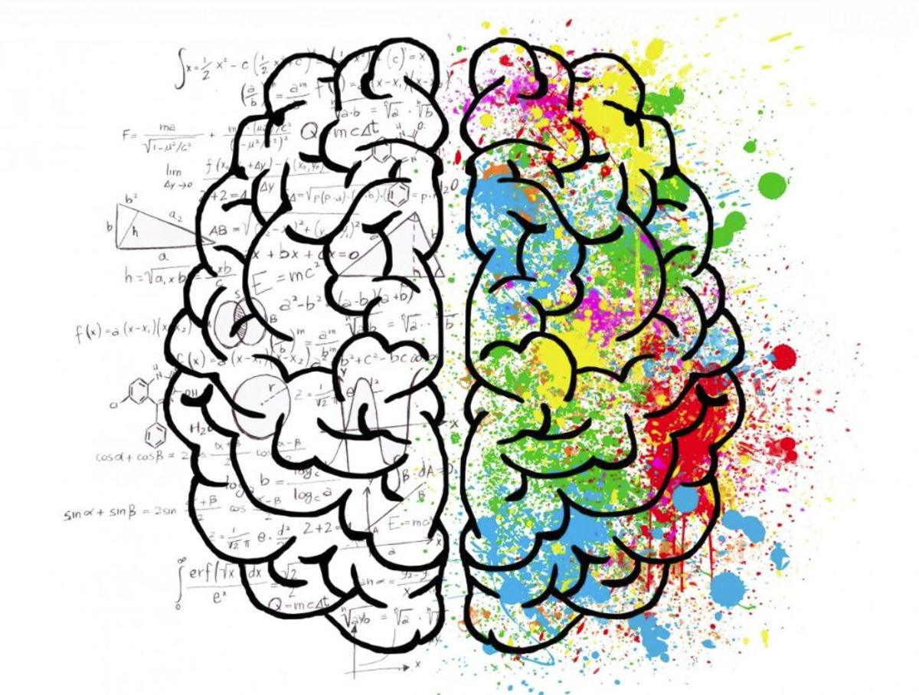

Welcome, year 11! This is you first ‘Bridging the Gap’ task for A level Psychology, which you’ve chosen to take at A level this September. The pack is designed to give you a flavour of what A level Psychology is all about. The pack will introduce you to some core psychological concepts and processes, to aid your understanding of psychology ready for sixth form. The second pack will be an independent research project. The work in these packs will take a long time, so you can break it up. Don’t feel you need to complete it all in one go! You can complete the tasks in this booklet in the spaces provided.
- If you require any support with these tasks please do not hesitate to get in touch via email mlipton@ripleyacademy.org or via the Microsoft Teams ‘groups chat’ I am in the process of creating
- If you wish to explore psychology in more depth, please sign up to the Y12 Psychology Seneca Learning group (www.senecalearning.com) it is free and I can track your progress. The class code is: c72rahx6mz
- Topics outlined Y13 Options topic below are subject to change based on staff specialisms
A Level course outline
Year 12: Intro to Psychology | Year 12-13: Applied Psychology | Year 13: Options in Psychology
Social Influences on behaviour | Approaches in Psychology | Issues & Debates in Psychology
Memory | Research Methods 1 | Relationships Psychology
Attachment in childhood | Research Methods 2 (advanced) | Schizophrenia
Psychopathology (mental health) | Biological psychology | Forensic Psychology

Task One: What is Psychology?
“Psychology is the scientific study of the human mind and behaviour.”
This really means we are trying to understand what it is that causes us to behave the ways we do; why are some people depressed? Why are some people introverted and some extroverted? Why do some people become killers? Why do some people become obese and some have anorexia? It’s a sensitive subject, but the focus is always on: why are humans the way they are?
Watch this short video to start you off: https://www.youtube.com/watch?v=1Os1C000qxY
Your first task is to help you garner an understanding of what Psychology is really all about. Use the internet (e.g. Wikipedia, YouTube and other sources) to research and understand what the following key terms mean and create a short definition for each in your own words.
The most important thing in an A level is your understanding – so it’s not about having the “right” or “word-perfect” definition, it’s about you understanding what a concept means ☺
Term | Explanation
Armchair psychology
Experiment
Observation
Self-report
Correlation
Ethical issues
Biological psychology
Behaviourist psychology
Psychodynamic psychology
Humanistic psychology
Cognitive psychology
Social psychology
Social learning theory
Obedience
Conformity
Phobia
Depression
OCD
Schizophrenia
Validity
Reliability
Nature-Nurture debate
Free Will – Determinism debate

Task Two: Psychological Research
“Psychology is the scientific study of the human mind and behaviour.”
Psychology is about more than just “thinking about” why we behave the ways we do. We have to conduct RESEARCH to back up our claims and find EVIDENCE to support it. Below are summaries of 5 famous psychological research studies and a series of questions for you to answer after each. If you are interested or want further information, there are great YouTube videos of these studies you can watch.
Milgram 1963
Aim: to investigate if American citizens would be obedient even if it meant harming others, or if Germans in World War II were just ‘evil’.
Method: a laboratory experiment
Sample: 40 American males between 20 and 50 years of age from the New Haven area.
Procedure: Participants were told they were taking part in a learning & memory experiment. They took the role of ‘teacher’, giving what they thought were painful shocks to an actor who they believed was a fellow participant. In truth, there were no shocks. The fake shocks increased from 15 volts (a bit of a painful shock) up to 450 volts (which would kill you).
Findings: 65% of Americans delivered 450V shocks (a lethal shock) to another citizen simply because they were told to do so whenever the actor pretended to get an answer wrong. 100% of the Americans delivered at least 300V shocks (also lethal) to another citizen.
Conclusions: Americans are no less ‘evil’ than Germans and in fact humans simply are compelled to obey authority, even if it may cause harm to other humans.
Questions:
- Do you think this is a good study? Are the findings useful? Why/why not?
- Are the findings convincing?
- Is the sample sufficient for the study or is it small/biased?

Piliavin, Rodin & Piliavin 1969
Aim: to investigate if people will help out someone who is suffering on a train, depending on their race, age, how many people are around and if the suffering person is drunk/old.
Method: a field experiment
Sample: around 4500 passengers on the New York subway.
Procedure: Experimenters got an actor to fake collapsing on the New York subway, and the number of people who helped and the time taken to help were recorded by secret (covert) observers. The race of the participants was also recorded. They changed the race of the actor, their gender and also whether or not they were pretending to be ill and collapsed or drunk and relaxed.
Findings: 79% of victims (who were actors) received help from participants, but this number fell to 50% for the “drunk” victim. There was a race effect: black people were more likely to help black victims and white people were more likely to help white victims. The more people that were present in the train, the more likely it was that the passenger would receive help.
Conclusions: Ill people are more likely to receive help than drunk ones, women are unlikely to intervene and help out men, there is a race effect in helping behaviour, and the more people are present the more likely people are to help. This study showed an example of helping behaviour in a real setting.
Questions:
- Why might it be a good thing that this study was conducted in a real subway instead of a lab like Milgram’s research?
- Is the sample of this study good?
- Why is it helpful/useful to know the conclusions this study found?
Loftus & Palmer 1974
Aim: to investigate if leading questions can actually change people’s memories of an event they witnessed.
Method: laboratory experiment
Sample: 195 students at American universities
Procedure: in study one, 45 students watched films of car crashes. They were then asked to estimate the car’s speed in response to a question. In the question, the verb used changed. The question was: “about how far were the cars going when the cars hit each other?” but the word hit could be changed to smashed, contacted, bumped or collided. In study two, 150 students went through the same process but later were asked if they had seen any broken glass at the scene (but there was no broken glass – it was a misdirect).
Findings: In study one, the ‘contacted’ condition led people to estimate the car was going at around 32mph but in the ‘smashed’ condition they estimated it was going at around 41mph. In study two, people who had the ‘smashed’ condition were more than twice as likely to report seeing broken glass at the scene, even though there was none.
Conclusion: the findings suggest that the way questions are worded can either change the memories of the participants or they indicate to participants that they should remember them in a certain way.
Questions:
- Why would this be useful for police interviewers? How might they change their questions?
- What is the problem with the fact that the car crashes were seen on videos? However – why did they HAVE to be videos and not real life?
- What are some of the ethical issues with the way the study was conducted?

Bandura, Ross & Ross 1961 & 1963
Aim: to investigate the extent to which children will repeat aggression that they’ve observed an adult doing on a doll.
Method: laboratory experiment
Sample: 72 children
Procedure: One group of children saw an adult attack an inflatable doll (called a Bobo doll) in a play room. Another group of children saw the adult behave in a friendly way with the doll. All the children were then deliberately frustrated (by being taken to a room with toys but not being allowed to play with them) and then were left in the room with the Bobo doll and observed.
Findings: Children who watched the aggressive adult also repeated highly aggressive behaviour. The children who had not seen the aggressive adult however were not aggressive with the Bobo doll. Boys were more likely to imitate an aggressive man and girls were more likely to imitate an aggressive woman. Some children even used hammers and fake guns on the doll, if they had seen the adults doing the same. If they had not observed an adult doing this, they would not do this.
Conclusions: Children are highly likely to imitate adult violence when given the opportunity to do so.
Questions:
- What does this study suggest about serious cases like the case of Jamie Bulger?
- What are the implications of this for letting children watch violent/horror movies and playing violent/horror video games?
- Is this a good study? What are some of the issues with the study?
Casey et al 2011
Aim: to test whether delaying rewards in childhood also leads to delaying rewards in adulthood
Method: a longitudinal natural experiment
Sample: 135 individuals completing a task at age 4 and again in their thirties.
Procedure: At age 4, a group of children were asked if they would have one cookie now or wait and get two cookies later. Their responses were recorded. They also conducted brain scans at the same time and found that one area of the brain (the inferior frontal gyrus) was associated with impulse control. In their thirties, they had to complete a questionnaire asking about their behaviour such as their gambling behaviour.
Findings: Participants who took the cookie ‘now’ (low impulse control) at age 4 also showed low impulse control in their thirties; this was related to low activity in the inferior frontal gyrus. Participants who waited for two cookies (high impulse control) at age 4 also showed high impulse control their thirties; this was related to high activity in the inferior frontal gyrus.
Conclusion: The ability to have impulse control and to resist temptation differs between individuals but is likely to be lifelong; it also seems to be a biological thing over which individuals have little say.
Questions:
- Do you agree with the findings that impulse control seems to be biological?
- Why might this be a questionable conclusion- think for example about rapists/serial killers…
- What does this show about the nature-nurture debate and the free will-determinism debate which you researched in Task One?
- What are the potential strengths/limitations of this study – do you think it is a good piece of research? Why or why not?

Task Three: Designing Research
Now that you’ve had a bit of an introduction to what psychology is all about and the all-important research focus of psychology, I want you to design your own research you will conduct on the issue given to you below. You do not HAVE to conduct the study (although you could if you wanted), but you do have to DESIGN the research. Your research question is as follows:
“Is there a relationship between how much time someone spends outside and happiness levels?”
Make sure to include the following information:
Why is this area of interest to psychologists? What use could the findings be?
How would you go about researching it? Be detailed.
Who might you choose to study? Why would they be a good sample?
What do you expect to find (or if you actually DO the study, what DID you find)?
Type this up as a ‘Research Design’ which should be approximately one typed A4 page.

