Source 1 – Cartoon ‘Justice’, Punch, September 1857
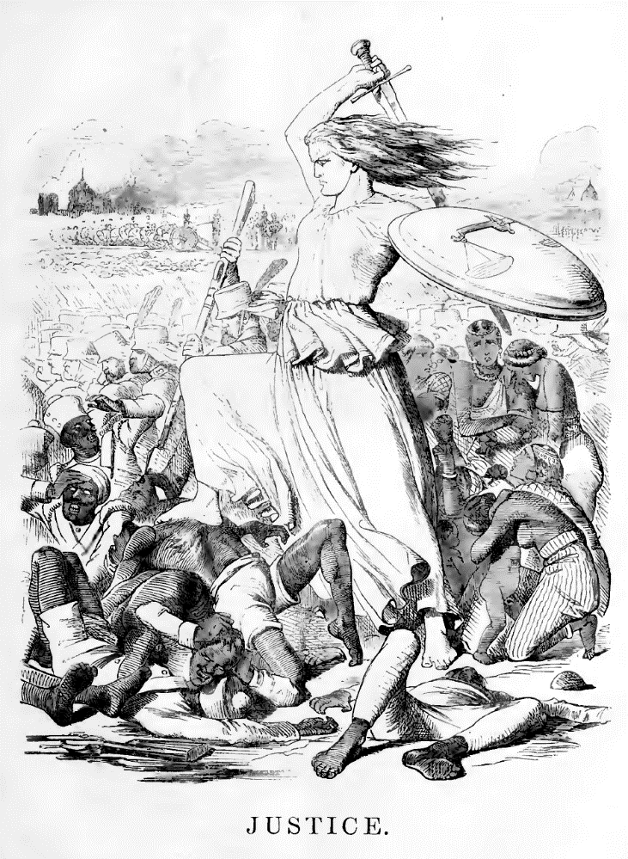

Note: In 1857 there was an uprising by Indian soldiers within the British East India Company’s army in Bengal, which turned into a widespread rebellion across India. British officers, their wives and children were slaughtered by rebelling Indian soldiers. It took the remainder of the year for the British in India to stamp out resistance.

Points of discussion:
- Who does the woman in white represent?

- Why do you think the cartoon chose to portray the Indians in this way?

- What can you infer about how the British viewed their position in India?

Source 2 – An extract from the poem ‘Take Up the White Man’s Burden’ by Rudyard Kipling, written in 1899

Take up the White Man’s burden, - a burden is a heavy load
Send forth the best ye breed, - send men from Britain to India
Go, blind your sons to exile, - exile means barred from one’s country
To serve your captives’ need; - captives are the Indian people
To wait, in heavy harness, - to serve the Indian people
On fluttered folk and wild, - implies they need civilising
Your new-caught sullen peoples, - Indian people are unhappy
Half devil and half child. - Not Christian and simple-minded

Note: Rudyard Kipling was born in Bombay, India in 1865. He worked in India as a journalist as a young man before returning to England to live there permanently. Kipling initially wrote the poem for Queen Victoria’s Diamond Jubilee but decided to submit a different poem. It took six months to travel to India from Britain.

Points of discussion:
- How are the Indian people described by Kipling?

- What do you think the poem is about?

- What can you infer from the poem about Kipling’s attitude towards the Indian people?

Source 3: An extract of lyrics from the rap group Public Enemy ‘Fight the Power’, written in 1989.
Elvis was a hero to most
But he never meant s*** to me you see
Straight up racist that sucker was
Simple and plain
Mother f***** him and John Wayne
Cause I'm black and I'm proud
I'm ready and hyped plus I'm amped
Most of my heroes don't appear on no stamps
Sample a look back you look and find
Nothing but rednecks for 400 years if you check
Don't worry be happy
Was a number one jam
Damn if I say it you can slap me right here
(Get it) let’s get this party started right
Right on, c'mon
What we got to say
Power to the people no delay
To make everybody see
In order to fight the powers that be
Lemme hear you say...
Fight the Power
Points of discussion:
- What do you think this rap is about?

- What can you infer about attitudes of black people in the US?

- What impact do you think this rap will have on those people who listen to it?
Source 4: A photograph of a lynching before a white crowd, in the state of Indiana, 1930
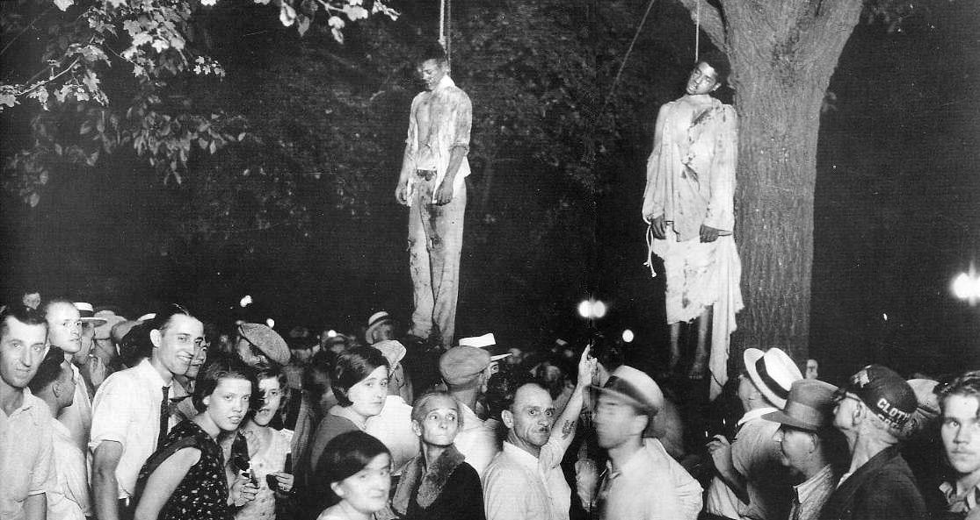

Note: Between 1880 and 1930, Southern whites lynched over 30,000 blacks, usually without trial. Law enforcement officers, politicians, editors and jurors colluded and/or often took part in these lynchings. Lynching demonstrated that black people had no legal protection. They were usually accused of rape. Southern whites defended lynching as a necessary defence of Southern white women against black rapists. The ‘black rapist’ myth was also used to justify segregation and economic discrimination.

Points of discussion:
- What has happened in the photograph?

- What can you infer about the attitude of the crowd to the lynchings?

- Why do you think this was allowed to happen in the USA?

