KEY TERMS: RESPIRATION, ANAEROBIC, AEROBIC, TIDAL VOLUME, VITAL CAPACITY, OXYGEN DEBT

Objective Discuss the long term effects of exercise on the respiratory system

Challenge: Explain the process of breathing and how it affects sporting performance and success (link to specific sports)

**C: THE RESPIRATORY SYSTEM**

Describe the process of Gaseous Exchange

_________________________________________________________________________________________________________________________________________________________________________________________________________________________________________________________________________________

__________________________________________

Identify the immediate and long term responses to exercise on the respiratory system

_____________________________________________________________________________________________________________________________________________________________________________________________________________________________________________________________________________________________________________________________________________________________________________________________________________________________________________________________________________________________________________________________________________________________________

Asthma

Altitude/change in partial pressure

USE THE EXTRA SPACE ON THE BACK!

Label the Respiratory System

DEFINE THE FOLLOWING TERMS

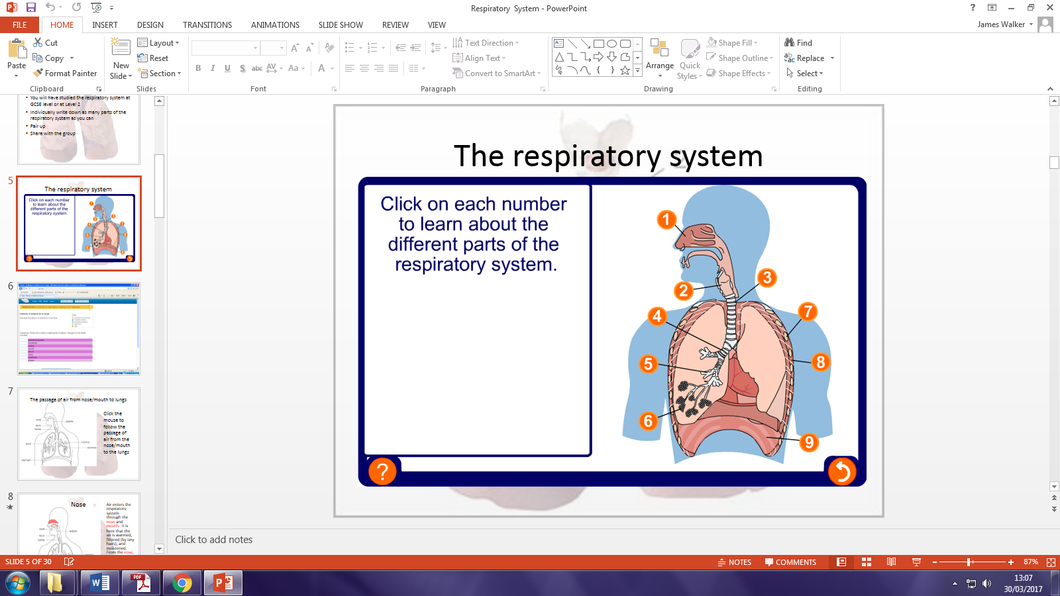

|  |  |
| --- | --- |
| Tidal volume. |  |
| Vital capacity. |  |
| Residual volume. |  |
| Total lung volume. |  |
| Pulmonary ventilation (VE). |  |

Describe and explain, using examples, both the immediate effects, and the long term effects of regular exercise on the respiratory system.

(6 MARKS)

EXTRA SPACE