**A Level Psychology Y11 Bridging the Gap 2**

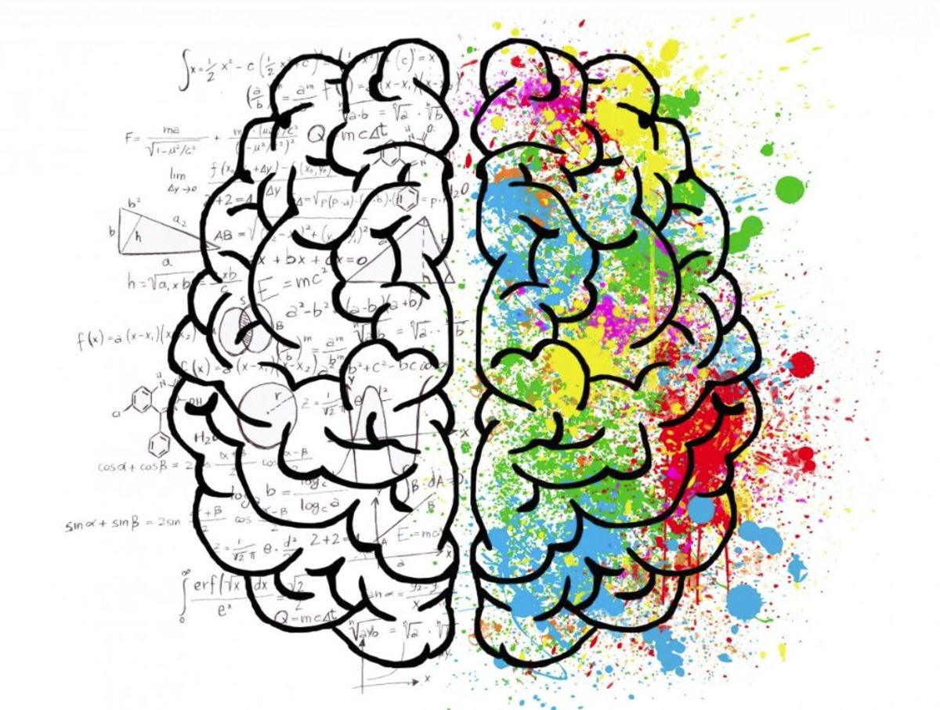

*Welcome, year 11! This is your second pack which will be three independent research projects. The work in these packs will take a long time, so you can break it up. Don’t feel you need to complete it all in one go!*

|  |  |  |
| --- | --- | --- |
| **A Level course outline** | | |
| **Year 12: Intro to Psychology** | **Year 12-13: Applied Psychology** | **Year 13: Options in Psychology** |
| Social Influences on behaviour | Approaches in Psychology | Issues & Debates in Psychology |
| Memory | Research Methods 1 | Relationships Psychology |
| Attachment in childhood | Research Methods 2 (advanced) | Schizophrenia |
| Psychopathology (mental health) | Biological psychology | Forensic Psychology |

Gender Research Task:

Your job is to do some preliminary research into the psychological concept of ‘gender’. You need to do some research into the psychological explanations of gender and produce a short information section; this could be an A5 (half an A4 page) flyer, or an A4 infographic, or even a short booklet – it’s up to you how you’d like to prepare this. You can then send me electronically, or a photograph of (if you do it by hand) your work. You need to consider:

What is the psychological concept of ‘gender’? How is it different from ‘sex’? What is gender identity disorder? What are some of the explanations of gender identity disorder?

What is androgyny? How can it be measured? Is gender a biological construct, a social (sociological) construct or is it part of our personality (or something else entirely)? How do psychologists explain gender development (chromosomes/genetics, from social learning in the environment, or Kohlberg’s cognitive theory)?

Stress Research Task:

Your job is to do some preliminary research into the psychological concept of ‘stress’. You need to do some research into the psychological explanations of & treatments for stress and produce a short information section; this could be an A5 (half an A4 page) flyer, or an A4 infographic, or even a short booklet – it’s up to you how you’d like to prepare this. You can then send me electronically, or a photograph of (if you do it by hand) your work. You need to consider:

What is stress? What are the biological and psychological characteristics of stress?

How can we measure people’s stress levels? What’s good/bad about these ways?

Does stress cause other (biological, non-mental health) illnesses?

What are the primary causes of stress? How might people reduce those causes?

Are some sorts of people more or less prone to stress than others?

Addiction Research Task:

Your job is to do some preliminary research into the psychological concept of ‘addiction’. You need to do some research into the psychological explanations of addiction and produce a short information section; this could be an A5 (half an A4 page) flyer, or an A4 infographic, or even a short booklet – it’s up to you how you’d like to prepare this. You can then send me electronically, or a photograph of (if you do it by hand) your work. You need to consider:

What is addiction? What are the biological & psychological characteristics of addiction? What kinds of things can people be addicted to?

What are the risk factors that make someone more likely or less likely to become addicted to something?

What are withdrawal symptoms, and why do they make it hard for people to get away from their addictions?

Why do people gamble? How is their gambling behaviour reinforced, leading to more gambling?

What are the cognitive theories of why people are addicted (cognitive biases)?

How can psychologists treat addiction?