Checkpoint Task

Cell Division

Task 1 Why does my cut heal?
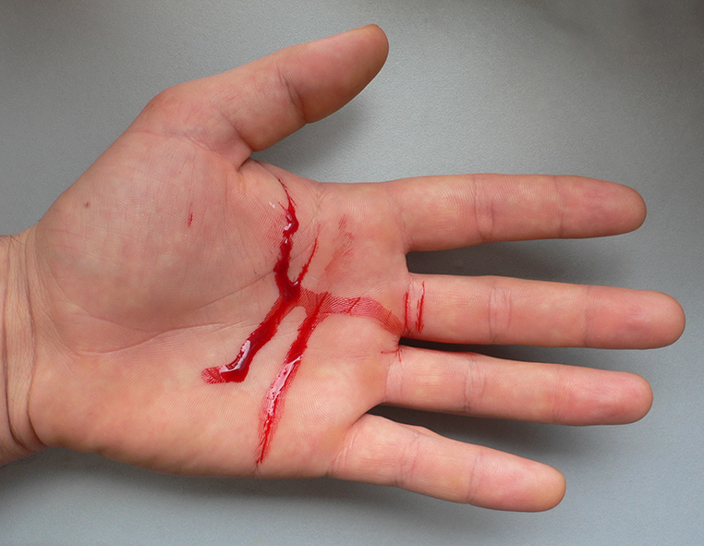

Your brother, who is 12, was preparing supper last night and cut his hand. Although there is quite a lot of damage to his skin new skin will form over the cut in a few weeks. He knows that this is something to do with cells being able to divide but he wants to know more details.
Your parents aren’t quite sure about the process and have asked you to explain it to him. So that you don’t have to go over it again and again produce a short video sequence showing how the cell divides to produce new skin cells. You will need to explain each stage. Make sure you use the correct terms listed below.
- Decide on what type of cell division it is
- Use the modelling clay to produce a model cell. Although human cells have 46 chromosomes you can simplify this so that your model has 4 chromosomes.
- Make a sequence of models and film them so that when finished you have a short video. At each stage you need to explain what is happening.

Terms to use:
- Chromosome
- Cytoplasm
- DNA
- Diploid and/or Haploid
- Mitosis or meiosis
- Nucleus

Task 2 How do sex cells form?
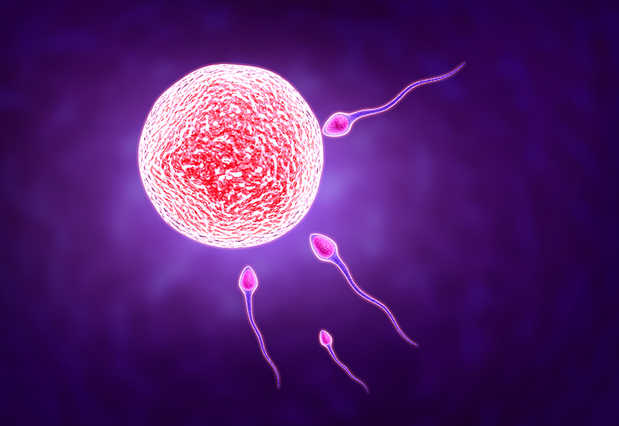

Your sister is in Year 7 and has been studying reproduction in science. She has come home very confused. “The teacher said we all have 46 chromosomes in our cells and that when an egg and a sperm meet the nuclei fuse. But if that happens, why don’t babies have 92 chromosomes?”
Your parents aren’t sure about it so they have asked you to explain it to her.
So that you don’t have to go over it again and again produce a short video sequence showing how sex cells are produced. You will need to explain each stage. Make sure you use the correct terms listed below.

- Decide on what type of cell division it is.
- Use the modelling clay to produce a model cell. Although human cells have 46 chromosomes you can simplify this so that your model has 4 chromosomes.
- Make a sequence of models and film them so that when finished you have a short video. At each stage you need to explain what is happening.
Terms to use:
- Chromosome
- Cytoplasm
- DNA
- Diploid and/or Haploid
- Mitosis or meiosis
- Nucleus

