Source 1 – A cartoon by John Tenniel, Punch, 15th April 1876
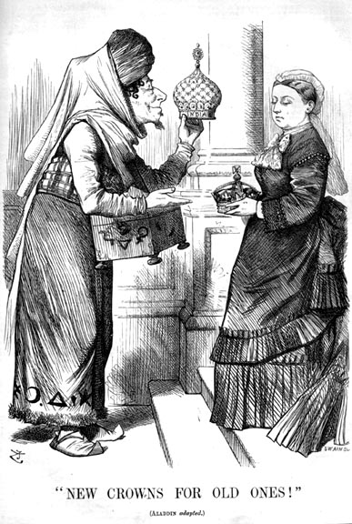

Note: The man on the left is the Prime Minister of Britain, Benjamin Disraeli. He is dressed up as Aladdin and offering a crown labelled ‘India’ to Queen Victoria. In 1876, Parliament granted Queen Victoria the title ‘Empress of India’.

Points of discussion:
- What is the story Aladdin about?

- What point is John Tenniel making in Source A?

- What can you infer about Britain’s connection with India?

Source 2 – Cartoon ‘Justice’, Punch, September 1857
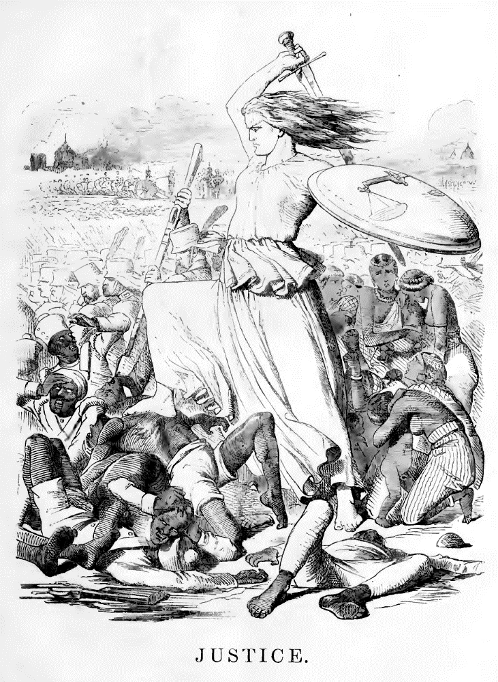

Note: In 1857 there was an uprising by Indian soldiers within the British East India Company’s army in Bengal, which turned into a widespread rebellion across India. British officers, their wives and children were slaughtered by rebelling Indian sepoys. It took the remainder of the year for the British in India to stamp out resistance.

Points of discussion:
- Who does the woman in white represent?

- Why do you think the cartoon chose to portray the Indians in this way?

- What can you infer about how the British viewed their position in India?

Source 3 – An extract from the poem ‘Take Up the White Man’s Burden’ by Rudyard Kipling, written in 1899
Take up the White Man’s burden -
Send forth the best ye breed –
Go, blind your sons to exile
To serve your captives’ need;
To wait, in heavy harness,
On fluttered folk and wild –
Your new-caught sullen peoples,
Half devil and half child.

Note: Rudyard Kipling was born in Bombay, India in 1865. He worked in India as a journalist as a young man before returning to England to live there permanently. Kipling initially wrote the poem for Queen Victoria’s Diamond Jubilee but decided to submit a different poem. It took six months to travel to India from Britain.

Points of discussion:
- How are the Indian people described by Kipling?

- What do you think the poem is about?

- What can you infer about Kipling’s attitude towards the Indian people?

Source 4 – A civil service office in Madras, India during the British Raj.

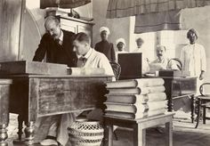

Note: The Indian Civil Service, or ICS were responsible for the administration of the whole of India. Although it was possible for Indians to work for the ICS it was very difficult for them to gain employment in reality and instead they served as policemen, lawyers and soldiers with British superiors.

Points of discussion:
- What do you think was the function of the Indian Civil Service?

- How important do you think the ICS was in India?

- What can you infer about the relationship between the British and the Indian people in India?

Source 5 – A British officer rides in state on an elephant to the maharajah’s palace during celebrations when a new maharajah succeeded to the throne
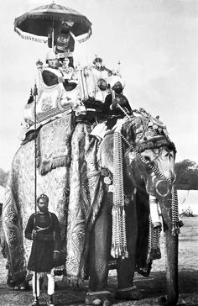

Note: Not all of India was governed directly by Britain. Vast areas of India were ruled indirectly through the Indian princes, or ‘maharajah’. Each ‘princely state’ was allowed to keep its own laws, languages, holidays, ministers and ruler; under the protection of British rule. However, these states could never act against British interests and the princes were not seen as equal allies.

Points of discussion:
- Why do you think British officials attended such ceremonies?

- Do you think it mattered that the British did not rule directly over the entire Indian sub-continent?

- What can you infer about the relationship between the British in India and the Indian princes?

