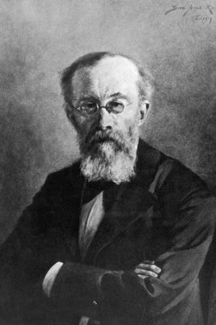
AQA A Level Psychology – Wilhelm Wundt

Wundt used reaction time as part of his method. How did he use this?
Why was this such an important event for Wundt but also for Psychology?

What did this make Wundt known as?
The three methods Wundt used were...

Experiments

Historical method

Introspection

Define the two terms:
Sensation

Perception
Wundt used a structuralist approach. Outline what is meant by this.
When and where was the first Psychology laboratory set up?
Identify Wundt’ life range.

How old was Wundt when he died?

