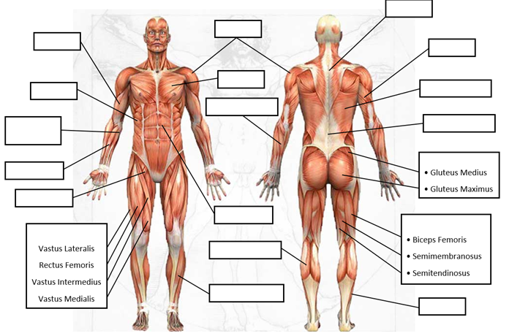

1

1111sd

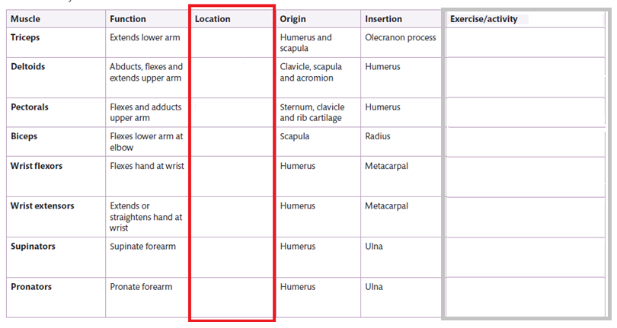

AGONIST – The contracting (working) muscle during a movement e.g. bicep is contracting during bicep curl.

ANTAGONIST – The relaxing muscle which supports the movement.

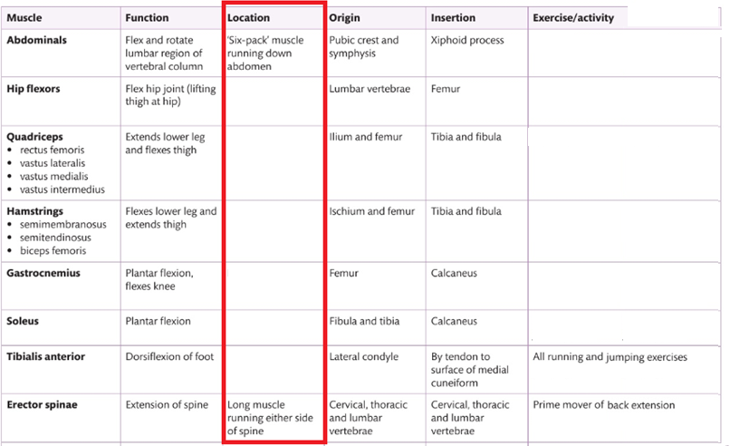

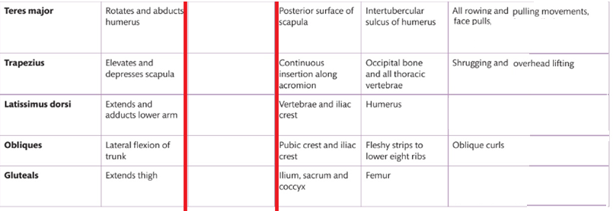

1