BBCs ‘Thinking Allowed’ some useful episodes for A Level Sociology

NB each episode on the BBC website includes a brief summary of what is included and a suggested reading list. Happy listening!

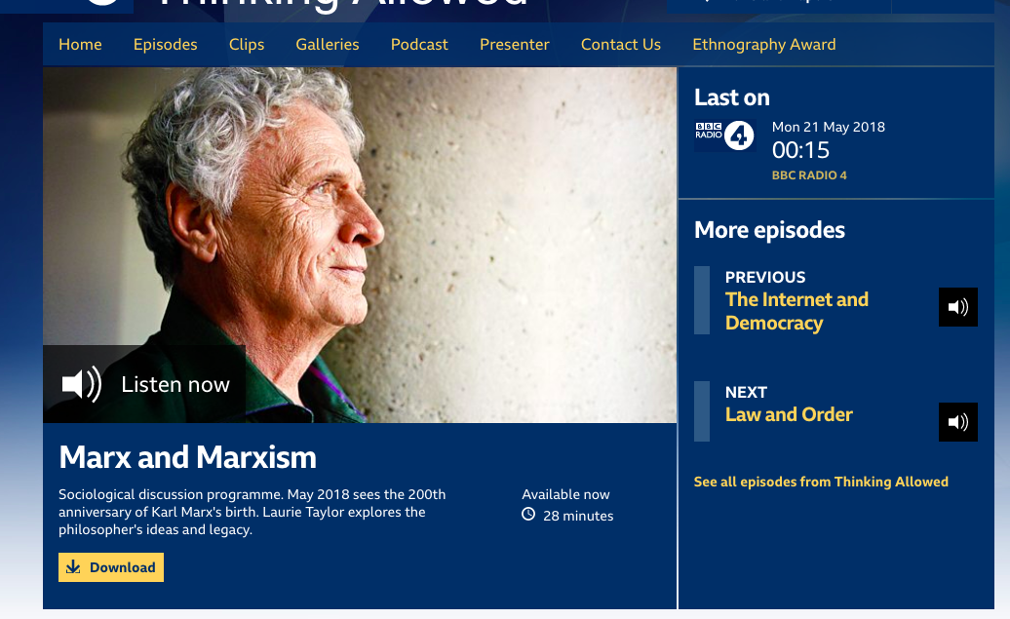

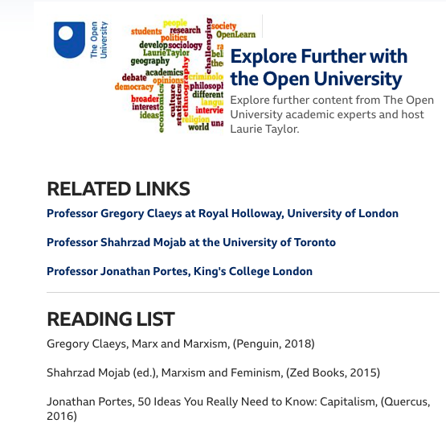

Social Theory

Marx and Marxism

https://www.bbc.co.uk/radio/play/b0b2kpm0

Marxism and Globalisation

https://www.bbc.co.uk/programmes/b006qy05/episodes/player?page=4

Alienation

https://www.bbc.co.uk/programmes/b006qy05/episodes/player?page=41

Pierre Bourdieu special

https://www.bbc.co.uk/programmes/b006qy05/episodes/player?page=12

Tribute to Ulrich Beck

https://www.bbc.co.uk/programmes/b04ykd77

Interview with Stuart Hall

https://www.bbc.co.uk/programmes/b006qy05/episodes/player?page=38

Tribute to Stuart Hall

https://www.bbc.co.uk/programmes/b006qy05/episodes/player?page=23

Goffman special

https://www.bbc.co.uk/programmes/b006qy05/episodes/player?page=25

Foucault special

https://www.bbc.co.uk/programmes/b038hg73

Stan Cohen special

https://www.bbc.co.uk/programmes/b006qy05/episodes/player?page=28

Research Methods

Ethnography awards 2018

https://www.bbc.co.uk/programmes/b09yfnn5

https://www.bbc.co.uk/programmes/b09z5lbq

Ethnography awards 2017

https://www.bbc.co.uk/programmes/b08ljfxg

https://www.bbc.co.uk/programmes/b006qy05/episodes/player?page=8

Ethnography 2016

https://www.bbc.co.uk/programmes/b006qy05/episodes/player?page=13

https://www.bbc.co.uk/programmes/b006qy05/episodes/player?page=13

Ethnography 2015

https://www.bbc.co.uk/programmes/b006qy05/episodes/player?page=17

https://www.bbc.co.uk/programmes/b05qgm0r

Study of Chungking mansions

https://www.bbc.co.uk/programmes/b013835n

The Family

Mixed-Race families

https://www.bbc.co.uk/programmes/b09xkdhd

Division of labour

https://www.bbc.co.uk/programmes/b05strvl

Living apart relationships- Sasha Roseneil – UCL- Social and Historical Sciences

https://www.bbc.co.uk/programmes/b006qy05/episodes/player?page=19

Romantic love

https://www.bbc.co.uk/programmes/b03mg95w

The nuclear family

https://www.bbc.co.uk/programmes/b01460f3

Single person household

https://www.bbc.co.uk/programmes/b013q3g3

Extended families

https://www.bbc.co.uk/programmes/b006qy05/episodes/player?page=36

Solo living

https://www.bbc.co.uk/programmes/b006qy05/episodes/player?page=45

Social Inequalities

Social Class

https://www.bbc.co.uk/programmes/b006qy05/episodes/player?page=3

The super rich

https://www.bbc.co.uk/programmes/b086s8yv

Meritocracy

https://www.bbc.co.uk/programmes/b006qy05/episodes/player?page=20

The Class Ceiling (Incudes Sociologist Sam Friedman)

https://www.bbc.co.uk/programmes/m000281t

Gender inequality in China

https://www.bbc.co.uk/programmes/b044h9pv

Neo-liberal economics

https://www.bbc.co.uk/programmes/b006qy05/episodes/player?page=24

Education

Elite Education- Inequality

https://www.bbc.co.uk/programmes/b08mbjqh

Higher education crisis in the US

https://www.bbc.co.uk/programmes/b07wc303

Social Mobility and Education

https://www.bbc.co.uk/programmes/b06j57f3

https://www.bbc.co.uk/programmes/b006qy05/episodes/player?page=44

The Attainment gap

https://www.bbc.co.uk/programmes/b007xnnb

Black girls and education

https://www.bbc.co.uk/programmes/b006qy05/episodes/player?page=47

Global higher education

https://www.bbc.co.uk/programmes/b00vcptj

Social Identity

Identity special

https://www.bbc.co.uk/programmes/m0001r8v

White Privilege- Racial Ambiguity

https://www.bbc.co.uk/programmes/m0000ykk

Cross class marriage

https://www.bbc.co.uk/programmes/b006qy05/episodes/player?page=16

The colour black, Mixed race identity

https://www.bbc.co.uk/programmes/b062kx4g

Social class survey

https://www.bbc.co.uk/programmes/b01s4qqs

Growing Chinese middle class

ttps://www.bbc.co.uk/programmes/m000254f

The colour yellow- how it became attached to people of Asian origin

https://www.bbc.co.uk/programmes/b015zqv9

Chavs

https://www.bbc.co.uk/programmes/b006qy05/episodes/player?page=37

Age

https://www.bbc.co.uk/programmes/m0002ml7
Snobbery (includes Sociologists David Morgan and Bev Skeggs)

https://www.bbc.co.uk/programmes/b007x4qq

Subcultures

https://www.bbc.co.uk/programmes/b006qy05/episodes/player?page=42

Religion

Islamophobia

https://www.bbc.co.uk/programmes/b006qy05/episodes/player?page=21

Muslim fundamentalism

https://www.bbc.co.uk/programmes/b006qy05/episodes/player?page=24

Religion and science

https://www.bbc.co.uk/programmes/b006qy05/episodes/player?page=41

Debate on the veil

https://www.bbc.co.uk/programmes/b008q04k

Religious Right in the US (includes Pew research centre statistics)

https://www.bbc.co.uk/programmes/m000bxjq

Media

Sociology of Twitter

https://www.bbc.co.uk/programmes/b03c48ys

Class and reality TV- with Bev Skeggs

https://www.bbc.co.uk/programmes/b00dhg7h

Selfies- disconnected from ICTs

https://www.bbc.co.uk/programmes/b0b89kc1

The internet and Democracy

https://www.bbc.co.uk/programmes/b0b1sycx

General

Rituals at Christmas

https://www.bbc.co.uk/programmes/b04vj6gx

The Brits who stayed in Hong Kong

https://www.bbc.co.uk/programmes/b006qy05/episodes/player?page=44

Chinese capitalism- interview with Will Hutton

https://www.bbc.co.uk/programmes/b006qy05/episodes/player?page=50

Globalisation- Joseph Stiglitz

https://www.bbc.co.uk/programmes/b006qy05/episodes/player?page=55

Study of Brick Lane

https://www.bbc.co.uk/programmes/b007ycdg

Migration in China

https://www.bbc.co.uk/programmes/b006qy05/episodes/player?page=59

Englishness

https://www.bbc.co.uk/programmes/b006qy05/episodes/player?page=59

Does Europe hate America

https://www.bbc.co.uk/programmes/b00773x9

