### Maths skills

#### 1 Measurements

###### Practice questions

|  |  |  |  |
| --- | --- | --- | --- |
| **Physical quantity** | **Equation used to derive unit** | **Unit** | **Symbol and name (if there is one)** |
| frequency | period−1 | s−1 | Hz, hertz |
| volume | length3 | m3 | – |
| density | mass ÷ volume | kg m-3 | – |
| acceleration | velocity ÷ time | m s−2 | – |
| force | mass × acceleration | kg m s-2 | N newton |
| work and energy | force × distance | N m (or kg m2 s−2) | J joule |

1. **a** 19 m **b** 21 s

**c** 1.7 × 10−27 kg **d** 5.0 s

1. Resistance 
2. **a** 5.7 cm ± 2% **b** 450 kg ± 0.4%

**c** 10.6 s ± 0.5% **d** 366 000 J ± 0.3%

1. **a** 1200 ± 120 W **b** 330 000 ± 1650 Ω
2. **D** 1400 ± 5 mm (Did you calculate them all? The same absolute error means the percentage error will be smallest in the largest measurement, so no need to calculate.)

#### 2 Standard form and prefixes

###### Practice questions

1. **a** 1.35×103 W (or 1.350 × 103 W to 4 s.f.) **b** 1.3×105 Pa

**c** 6.96×108 s **d** 1.76×1011 C kg−1

1. **a** 2 260 000 J in 1 kg, so there will be 1000 times fewer J in 1 g: 

**b** 1 kJ = 1000 J, 

**c** 1 MJ = 1000 kJ, so 

1. **a** 2.5×10−3 m **b** 1.60×10−15 m

**c** 1×10−8 J **d** 5×103 m

**e** 6.2 × 10−1 N

1. **a** 2.5 μm **b** 1.60 fm

**c** 10 nJ **or** 0.01 μJ **d** 5 km

**e** 0.62 N **or** 62 cN

1. **a** 0.009 m = 9×10−3 m = 9 mm

**b** 1×10−5 m = 1 × 10 × 10−6 m = 10 × 10−6 m = 10 μm

**c** 4.7×10−7 m = 4.7 × 100 × 10−9 m = 470 × 10−9 m = 470 nm

1. **a** 64000000 **or** 6.4 × 107 **b** 99.99

**c** 800 **d** 103

1. **a** 3.0×108 m s−1 ÷ 3.03×10−7 m = 1.0×1015 Hz

**b** 3.0×108 m s−1 ÷ 1000 m = 3.0×105 Hz

**c** 3.0×108 m s−1 ÷ 1.0×10−10 m = 3.0×1018 Hz

#### 3 Resolving vectors

###### Practice questions

1. **Scalars:** density, electric charge, electrical resistance, energy, frequency, mass, power, temperature, voltage, volume, work done

**Vectors:** field strength, force, friction, momentum, weight

1. **Scalars:** 3 ms−1, 50 km, 273 °C, 50 kg, 3 A

**Vectors: +**20 ms−1, 100 m NE, −5 cm, 10 km S 30°W, 3 × 108 m/s upwards

1. 13 kN
2. **Free body force diagram: Triangle of forces:**

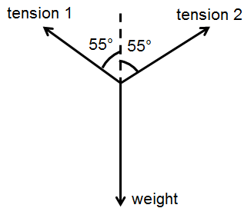 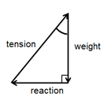

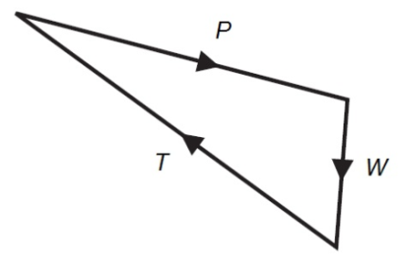

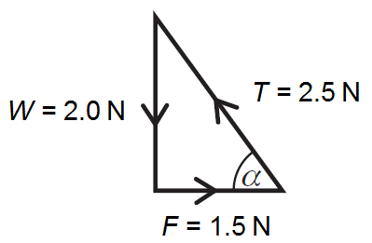

1. **a** 5.0N at 37° to the 4.0 N force **b** 13 N at 23° to the 12.0 N force

#### 4 Rearranging equations

###### Practice questions

1. *V* = 12 V and *I* = 0.25 A

*V = I R* so 12 = 0.25 × *R*

*R* =  = = 48 Ω

1. *λ* = 650 nm = 650×10−9 m and *v* = 3.0×108 m/s

*v* = *f* *λ* so 3.0×108 = *f* × 650×10−9

*f* == = 0.00462×1017 = 4.62×1014 Hz

1. *E* = 4.01×104J and *m* = 0.120 g = 0.120 kg

*E* = *mL* so 4.01×104= 0.120 × *L*

*L* = = 334 166 J/kg = 3.34×105 J/kg in standard form

#### 5 Work done, power, and efficiency

###### Practice questions

1. 22×103 N × 2×103 m = 44 000 000 J = 44 MJ
2. = 125 m
3.  = 13 541.6 W = 14 000 W or 14 kW (2 s.f.)
4.  = 7500 W = 7.5 kW
5.  × 100 = 75%
6. = 71%
7. = 94%
8. 0.74 s