Year 6 to Year 7 English Transition Booklet

Literary Techniques – Match the technique to the correct definition and then write an example of the technique.
Poetic Technique | Definition | Example
Simile | the comparison of two unlike things by saying one IS the other
Metaphor | a word or phrase to stimulate your memory into imagining a picture
Alliteration | the giving of human traits to non-human things
Onomatopoeia | the repetition of a beginning sound
Imagery | repetition of a word to add emphasise
Personification | similar sounding words
Repetition | the beat in a poem to make it sound like a song
Rhyme | comparing one thing to another using ‘like’ or ‘as’
Rhythm | the sound a thing makes
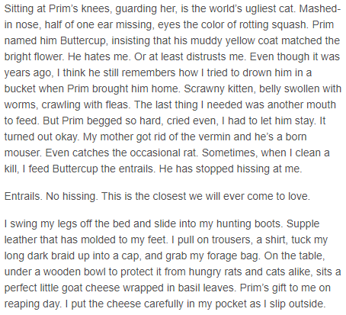

Are any of the devices from the previous page evident in the above extract from The Hunger Games? Add your own examples of any that are missing!
____________________________________________________________________________________________________________________________________________________________________________________________________________________________________________________________________________________________________________________________________________________________________________________________________________________________________________________________________________________________________________________________________________________________________________________________________________________________________________________________________________________________________________________________________________________________________________________________________________________________________________________________________________________________________________________________________________________________________________________________________________________________________________________________________________________________________________________________________________________________________________________________________________________________________________________________________________________________________________________________________________________________________________________________________________________________________________________________________________________________________________________________________

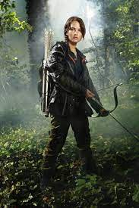

Write a description of Katniss Everdeen (image above). You could describe her appearance, how she feels about entering an arena for battle, her emotions, the setting around her etc. Challenge: Try to incorporate four of the devices from the previous task! ______________________________________________________________________________________________________________________________________________________________________________________________________________________________________________________________________________________________________________________________________________________________________________________________________________________________________________________________________________________________________________________________________________________________________________________________________________________________________________________________________________________________________________________________________________________________________________________________________________________________________________________________________________________________________________________________________________________________________________________________________________________________________________________________________________________________________________________________________________________________________________________________________________________________________________________________________________________________________________________________________________________________________________________________________________________________________________________________________________________________________________________________________________________________________________________________________________________________________________________________________________________________________________________________________________________________________________________________________________________________________________________________________________________________________________________________________________________________________________________________________________________________________________________________________________________________________________________________________________________________________________________________________________________________________________________________________________________________________________________________________________________________________________________________________________________________________________________________________________________________________________________________________________________________________________________________________________________________________________________________________________________________________________________________________________________________________________________________________________________________________________________________________________________________________________________________________________________________________________________________________________________________________________________________________________________________________________________________________________________________________________________________________________________________________________________________________________________________________________________________________________________________________________________________________________________________________________________________________________________________________________________________________________________________________________________________________________________________________________________________________________________________________________________________________________________________________________________________________________________________________________________________________________________________________________________________________________________________________________________________________________________________________________________________________________________________________________________________________________________________________________________________________________________________________________________________________________________________________________________________________________________________________________________________________________________________________________________________________________________________________________________________________________________________________________________________________________________________________________________________________________________________________________________________________________________________________________________________________________________________________________________________________________________________________________________________________________________________________________________________________________________________________________________________________________________________________________________________________________________________________________________________________________________________________________________________________________________________________________________________________________________________________________

At The Ripley Academy, we love to read!
1: What is your favourite book? What happens Why is it your favourite?
__________________________________________________________________________________________________________________________________________________________________________________________________________________________________________________________________________________________________________________________________________________________________________________________________________________________________________________________________________________________________________________________________________________________________________________________________________________________________________________________________________________________________________________________________________________________________
2: Read a new book over the Summer and track what happens below!

Date | Title of book | Start page | Stop page | Summary of reading

